Assignment 8

STEP I: MySQL Integration for Relational Data

Part 2
1. Implementations
(1)RDS MySQL setup
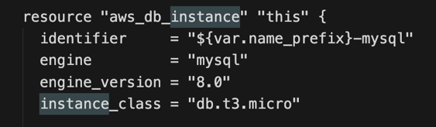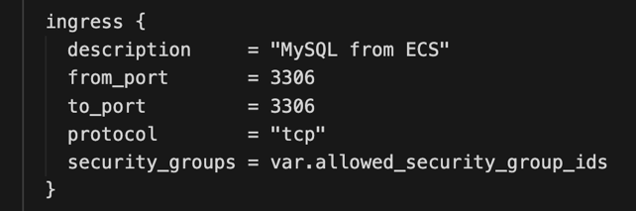
(2) Connection Pooling and Schema Design
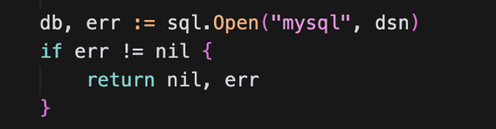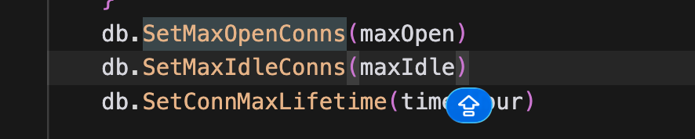
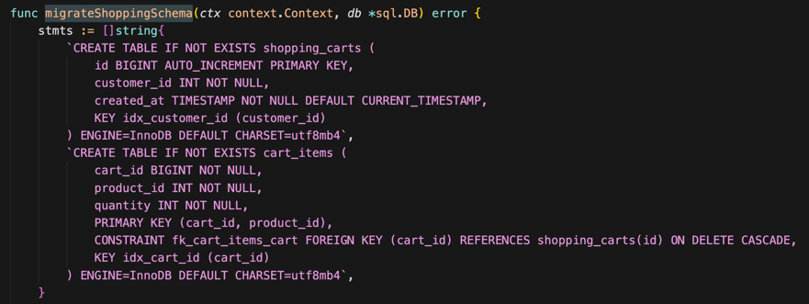
(3) API endpoints:
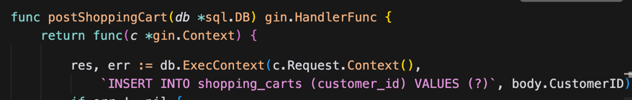
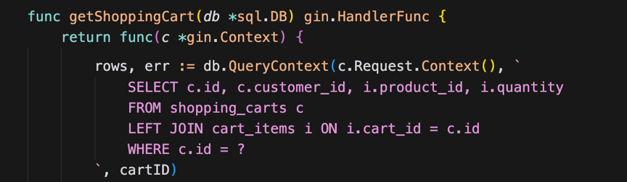
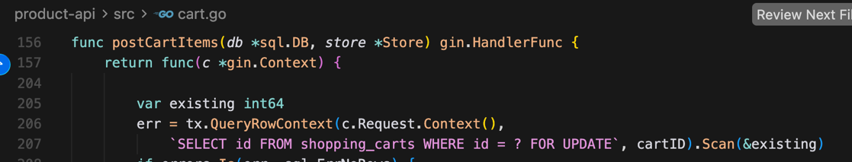
(4) Customer history query (supported by schema):
SELECT id, customer_id, created_at
FROM shopping_carts
WHERE customer_id = ?
ORDER BY created_at DESC;
Reason: I added index idx_customer_id on shopping_carts(customer_id), so this query is efficient for listing carts by customer.
2. My Design Decisions:
(1) Schema Design: How many tables? What fields in each?
I used two tables: shopping_carts and cart_items.
shopping_carts
- id (BIGINT, auto-increment): primary key for each cart.
- customer_id (INT, NOT NULL): who owns the cart (for “all carts by customer” queries).
- created_at (TIMESTAMP): when the cart was created (useful for ordering / history-style queries).
cart_items
- cart_id (BIGINT): which cart the row belongs to.
- product_id (INT): which product (validated in the app against the in-memory product list).
- quantity (INT): how many units.
Each row in cart_items is one product line inside one cart. I did not put items inside a JSON column in shopping_carts, because separate rows are easier to update with SQL and match the “relational” part of the assignment.
(2) Key Strategy: Primary keys, foreign keys, and constraints
shopping_carts: primary key is id.
cart_items: composite primary key (cart_id, product_id). This guarantees at most one row per (cart, product), so we do not get duplicate lines for the same SKU.
Foreign key: cart_items.cart_id references shopping_carts(id) with ON DELETE CASCADE. If a cart row is deleted, all its line items are removed automatically, so we avoid orphan rows in cart_items.
I did not add a foreign key to a products table because in my project products are still loaded in memory, not stored in RDS. The API checks product_id in code before add/update.
(3) Index Strategy: Which columns need indexes for your access patterns?
shopping_carts.customer_id — non-unique index (idx_customer_id).
Why: Access pattern “list all carts for one customer” filters by customer_id. An index makes this scan cheaper when there are many carts.
cart_items primary key (cart_id, product_id) — already supports “get / upsert one line” by cart and product.
Extra key on cart_items(cart_id) (idx_cart_id) — helps joins and queries that load all lines for one cart (e.g. JOIN ... ON cart_items.cart_id = shopping_carts.id with WHERE shopping_carts.id = ?). The left prefix of the composite PK also includes cart_id, so in practice the optimizer may use the PK; I still documented this index for clarity in the assignment.
Main read path for performance testing: get full cart by id uses one query joining the two tables on cart_id, which should stay fast for “up to 50 items” per cart.
(4) Transaction Design: How to handle concurrent cart modifications?
I use InnoDB transactions with short critical sections.
For add/update or remove item:
1) BEGIN
2) SELECT id FROM shopping_carts WHERE id = ? FOR UPDATE
-> this locks only that cart row, so two requests on the same cart are serialized
3) Run INSERT ... ON DUPLICATE KEY UPDATE (for add/update) or DELETE (for remove item)
4) COMMIT
This prevents race conditions (like lost updates) on the same cart. For different cart IDs, transactions usually do not block each other, so concurrency is still good.
3. Document Your Choices
(1) Why this table structure
I used two tables: shopping_carts and cart_items. This is a simple one-to-many design. One cart can have many items. It is easy to read, update, and maintain.
(2) What indexes and why
Customer id for history / listing by customer; composite PK for uniqueness and upsert; cart id on line items to support joins and “all items for this cart.”
(3) Cart–item relationship
Implemented as 1-to-many using cart_id in cart_items and a foreign key + cascade delete, so the relationship is enforced by the database, not only by the application.
(4) Trade-offs
Pros: Clear schema, FK integrity, simple SQL for grading and debugging.
Cons: Getting a cart needs a JOIN instead of one JSON blob; for at most 50 lines this is still cheap.
Products not in RDS means referential integrity for product_id is only in the app layer unless we add a products table later.
3. Document Your Learning Journey
At first, I wanted to store the whole cart as one JSON row because it looked simple. After implementation, I changed to two tables (‘shopping_carts’ and ‘cart_items’) because MySQL indexes and foreign keys are easier in this design.

I learned that transaction + ‘SELECT ... FOR UPDATE’ is important for concurrent updates on the same cart. I also learned ‘ON DUPLICATE KEY UPDATE`’must match API semantics, so in my code quantity means the new value for that product.

One thing I misunderstood at first: ‘ON DELETE CASCADE’ only works when the cart row is deleted. To remove one item, I still need ‘DELETE FROM cart_items WHERE cart_id=? AND product_id=?’.

For optimization, I used connection pooling and one JOIN query for cart read, instead of many small queries.

Part 3

1. Initial approach:
At first, I used in-memory cart data for quick implementation. Then I moved cart data to MySQL for persistence and better data integrity.

2. Iterations:
I first implemented basic insert/select. After that, I added transaction with FOR UPDATE for concurrent cart updates and ON DUPLICATE KEY UPDATE for item upsert.

3.Connection pooling decision:
I used database/sql pool settings (max open, max idle, conn lifetime). This helps avoid too many connections and keeps DB access stable.

4. Performance observations:
My first end-to-end GET cart test from local machine was around 59 ms average. I think network latency is included, not only DB query time. I did warm-up test and will use the 150-operation test for final comparison.

5. Schema changes:
I used two tables: shopping_carts and cart_items. I added index on customer_id and FK with ON DELETE CASCADE. This supports customer history query and prevents orphan cart items.

6. Valuable learning moments:
I learned that transaction + FOR UPDATE is important for same-cart concurrency.

I also learned cascade delete does not replace deleting one item row. For single item remove, I still need DELETE on cart_items.

Part 4
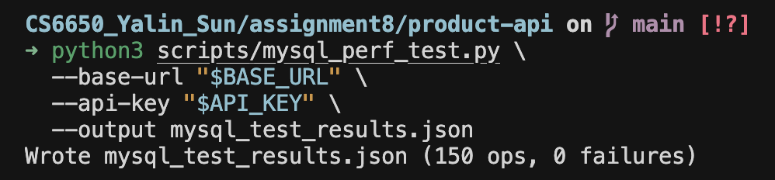

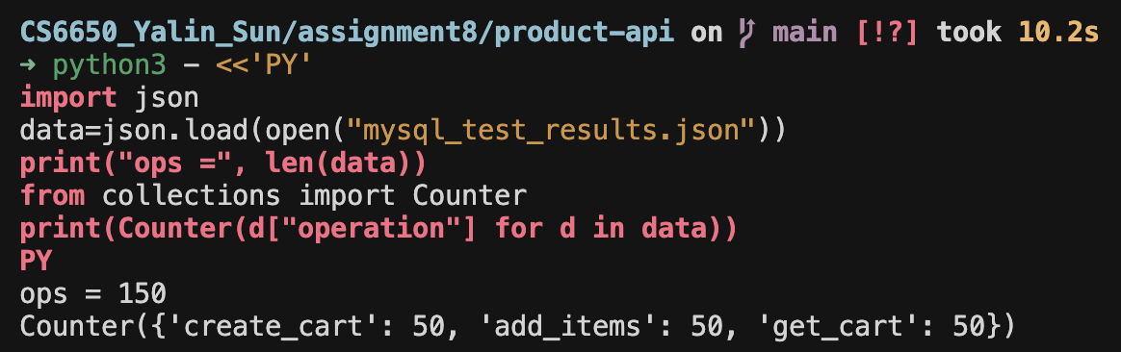

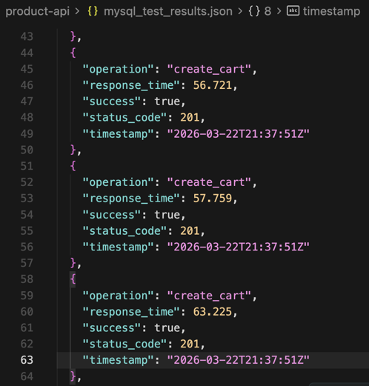

1. Test protocol:
I ran exactly 150 operations within 5 minutes: 50x POST /shopping-carts, 50x POST /shopping-carts/{id}/items, 50x GET /shopping-carts/{id}. The script saved all results into mysql_test_results.json.

2. Result file:
Each record includes operation name, response_time (ms), success flag, status_code, and UTC timestamp. In my run, there were 0 failures.

3. Observation:
The average end-to-end latency is around ~65 ms in my environment. This test is executed from my local machine to the ECS public endpoint, so network RTT is included.

Part 5
1. Did your initial schema meet performance requirements?
Functionally yes (cart + items, no orphan items).
For performance, my first measurement did not meet <50 ms average in my environment. I think it is because the test is end-to-end and includes network RTT.
2. Were any queries slower than expected?
POST /shopping-carts/{id}/items was slightly slower than I expected because it uses a transaction and a lock step (FOR UPDATE) plus an upsert.
I also saw one GET cart request has a big spike (one request around ~200 ms). It looks like an occasional network or system jitter.
3. What database concepts were new to you?
A new concept for me is row-level locking with SELECT ... FOR UPDATE, and how it helps prevent lost updates on the same cart.
4. What didn’t work at first?
I misunderstood ON DELETE CASCADE. It only deletes items when the cart row is deleted, it does not remove one product line item. I had to implement a separate DELETE FROM cart_items WHERE cart_id=? AND product_id=?.
I also learned that my local computer cannot connect to RDS directly, because RDS is in private subnet and only ECS security group is allowed (this is correct by design).
5. How did you optimize for the test requirements?
I used indexes (customer_id) and JOIN for reading the cart in one query (avoid N+1 queries).
I used connection pooling (MaxOpenConns, MaxIdleConns, ConnMaxLifetime) to keep DB connections stable.
I wrote a script to run exactly 150 operations and save results into mysql_test_results.json.
6. What would you do differently next time?
Run performance tests inside AWS (same region/VPC) to reduce public network latency and measure backend performance more accurately.
Add more monitoring (CloudWatch metrics and logs) earlier to understand spikes and connection behavior.
Part 6
Figure 1. RDS CPUUtilization
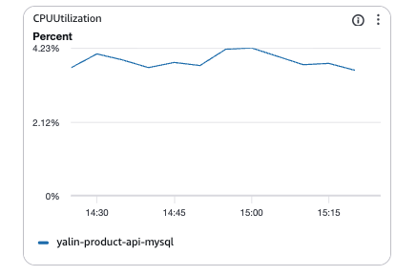
CPU stayed low (<~5%), so DB is not CPU bottleneck in this run.
Figure 2. RDS DatabaseConnections
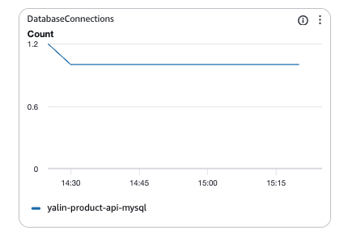
Connections stayed stable (~1–2). This matches my connection pooling settings.
Figure 3. RDS ReadIOPS
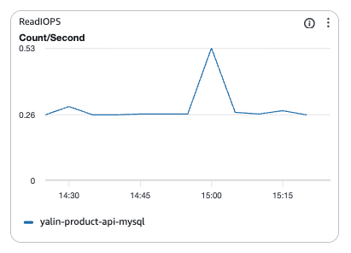
Read IOPS is low with small spikes, which is expected for simple cart queries.
Figure 4. RDS WriteIOPS
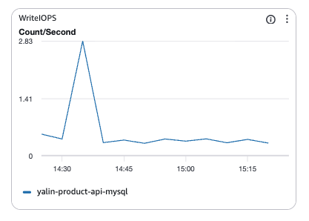
RDS WriteIOPS during the test.
Write IOPS spikes happen during create cart and add items operations.
Figure 5. RDS FreeStorageSpace
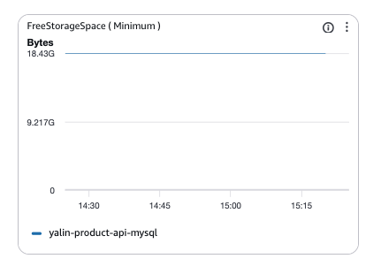
Storage is stable, no storage pressure.
Figure 6. ECS CPU/Memory Utilization
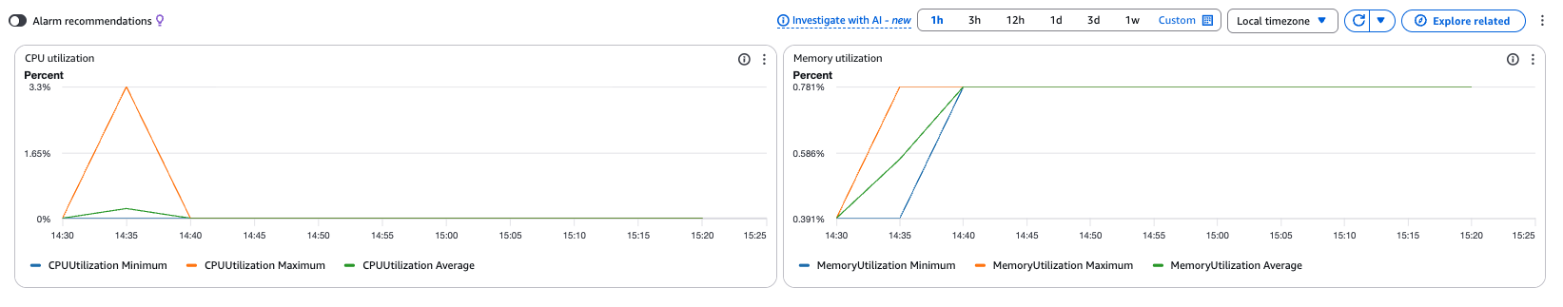
Resource usage increased during the test but stayed within safe range.
Figure 7. API latency summary from mysql_test_results.json
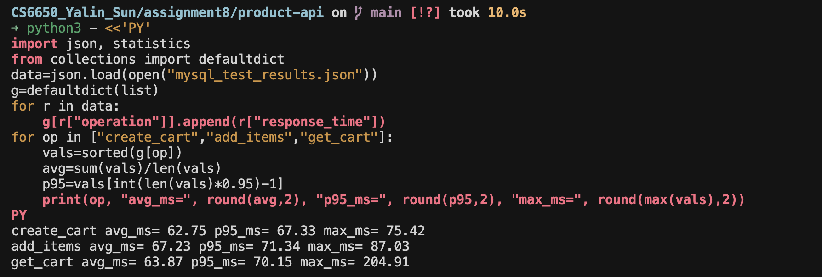
This is end-to-end latency from local machine to ECS public endpoint, so network RTT is included.
Analysis:
CloudWatch metrics show RDS CPU and connections stayed low and stable during the 150-operation test.
ReadIOPS/WriteIOPS had small spikes that match create and add-item operations.
ECS CPU/Memory also stayed stable.
The API end-to-end latency (from mysql_test_results.json) is around ~65 ms on average, which likely includes public network RTT.
Section Conclusions
1. Load test data comparing Week 5 vs MySQL performance
Item | Week 5 (In-memory, Locust) | Step I (MySQL, 150 ops script)
Workload type | Mixed GET/POST (3:1), 50 users | Fixed 150 ops (50/50/50)
average response time | ~31 ms | ~65ms
Median latency | ~28–30 ms | ~63ms
P95 latency | ~35–45 ms | ~67–71 ms
Failures | 0% | 0%
Persistence | No (memory only) | Yes (RDS MySQL)
2. Connection Pool Behavior
I use Go database/sql connection pool:
- MaxOpenConns default 25 (configurable)
- MaxIdleConns default 10 (configurable)
- ConnMaxLifetime 1 hour
In CloudWatch, RDS DatabaseConnections stayed stable (about ~1–2), so the pool did not create too many connections.
3. Implementation Notes
(1) Schema decisions and rationale
I used two tables because it is clear 1-to-many design (cart → items).
It supports JOIN read, customer history index, and FK integrity for cart-item relationship.
(2) Key challenges
RDS is in private subnet, so my local machine cannot connect directly (correct security design). Only ECS can access DB.
I first misunderstood ON DELETE CASCADE. It only deletes items when deleting the cart, not deleting one line item. So I used a separate DELETE query for removing one item.
(3) Performance observations and pool insights
My MySQL end-to-end latency is around ~60–70 ms average, which is higher than Week 5 in-memory result.
I think it is because MySQL adds DB round-trip cost and my test includes public network RTT to ECS public IP.
Connection count stayed stable, so pooling looks correct for this workload.
(4) Brief comparison with Week 5
Week 5 in-memory is faster, but it is not persistent.
MySQL version is slower end-to-end, but it provides persistence and stronger data integrity (FK for cart-item), and supports customer history queries.
STEP 2: DynamoDB Integration instead of NoSQL
Part 1
1. Design Decisions
(1) Partition key strategy
I use one DynamoDB table with composite primary key pk (hash) + sk (range).
For each cart, pk = "CART#<cart_id>". Different carts have different pk values, so requests spread across many partitions. This helps even distribution when there are many active carts.
There is also a small helper item pk=SYSTEM, sk=CART_COUNTER to generate numeric shopping_cart_id, so the API stays the same as Step I (MySQL). This counter item gets more writes, but it is only one item and cart reads still use different partitions.
(2) Sort key
Yes, I need a sort key sk because one cart has one META row and many ITEM rows. I store:
sk = META for customer_id and created_at
sk = ITEM#<product_id> for each product line and quantity
(3) Single table vs multiple tables
I chose single-table design to keep all cart data in one place and use Query on the same pk to read the full cart in one round trip.
(4) Items: embedded vs separate attributes
I use separate items (one DynamoDB item per product line), not one big embedded map. It is easy to update one product with PutItem, and it matches how I think about “line items” in Step I.
(5) Secondary indexes
I did not add a GSI because the homework API only needs get cart by id. Listing all carts by customer is optional; if we need that later, we can add a GSI on customer_id.
2. Approaches
(1) How cart–item relationship works (DynamoDB vs MySQL)
In MySQL I used two tables and a foreign key. In DynamoDB, the relationship is modeled by sharing the same pk: META and ITEM rows belong to the same cart. To remove dependency on SQL joins, I use Query with pk = CART#id.
(2) Consistency (eventual consistency)
DynamoDB is eventually consistent on some read paths. For cart reads in my implementation, I use ConsistentRead = true on GetItem / Query when I load a cart, because I want correct results right after writes during testing. I still learned that write propagation and application-level retries matter in distributed systems.
(3) Trade-offs
Pros: simple access pattern, on-demand billing, scales with many carts, API matches Step I.
Cons: the counter item can be a small hotspot for creates; GSI costs extra if we add customer history later.
(4) Compared to MySQL:
no SQL joins; instead I use Query and multiple items under one partition key.
3. Learning journey
At first I thought about one JSON document per cart in a single item. Then I switched to META + ITEM# rows because updating one product is easier and the design is closer to relational “line items”. I validated the design by running the same 150-operation test as Step I and checking CloudWatch metrics for throttling (should be low with on-demand).
Part 2
1. Implementations
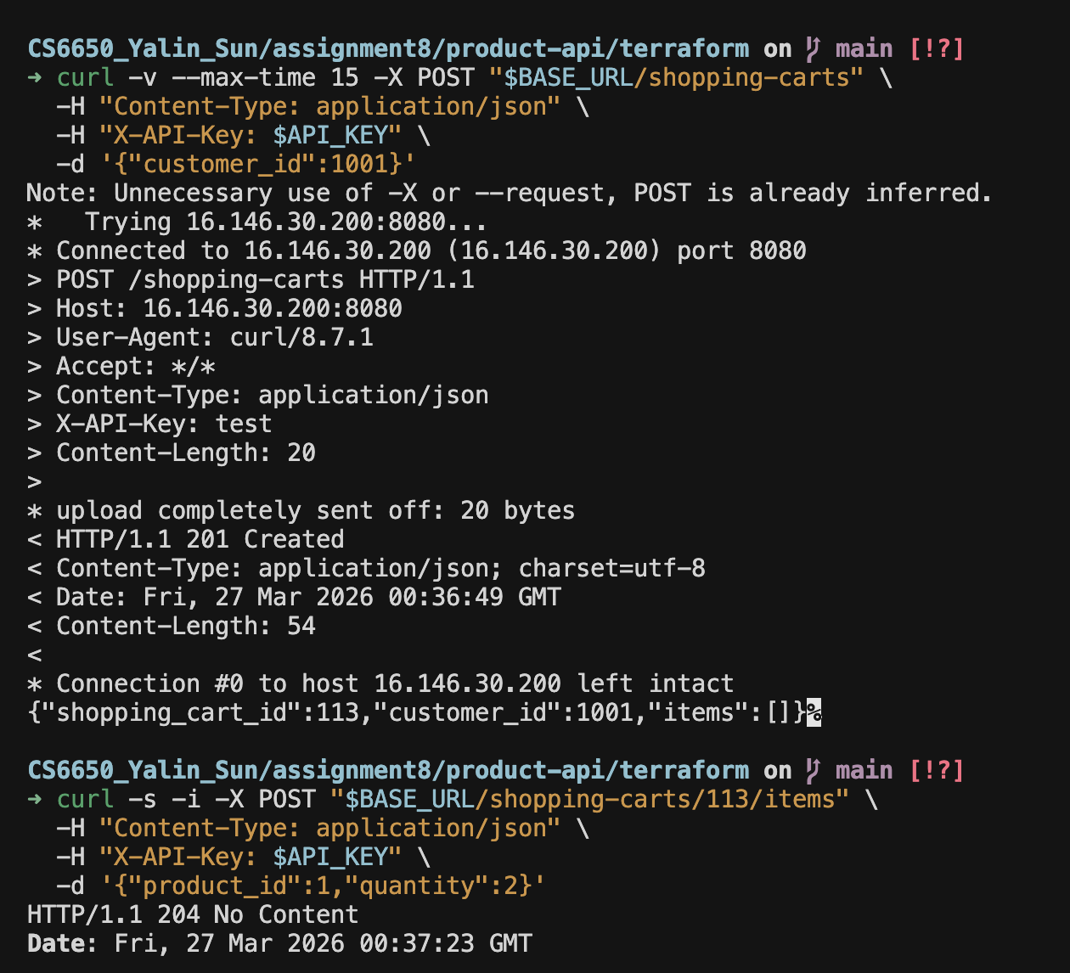
2. Investigation Questions
1) How does DynamoDB’s attribute value format affect your application data structures?
DynamoDB stores attributes as typed values (String, Number, Map, List, etc.). In Go I use types.AttributeValueMemberS for pk, sk, and created_at, and AttributeValueMemberN for customer_id, quantity, and product_id. Numbers must be written as decimal strings (for example "3"), not raw Go int in the attribute struct. So my JSON API still uses normal JSON numbers, but when I call DynamoDB I convert them to string numbers for N types. This is a bit different from MySQL where the driver maps types automatically.
2) What DynamoDB operations are most appropriate for each endpoint?
POST /shopping-carts: I use UpdateItem with ADD on the SYSTEM / CART_COUNTER row to get a new id, then PutItem for the META row under CART#id.
GET /shopping-carts/{id}: I use Query on pk = CART#id to read META and all ITEM#... rows in one request (same partition key).
POST /shopping-carts/{id}/items: I first GetItem on META to check the cart exists, then PutItem for the line item (ITEM#productId).
GetItem is enough for a single key lookup; Query fits when I need all rows under one cart partition key.
3) How do you handle eventual consistency in your operations?
DynamoDB reads can be eventually consistent by default. For cart reads I set ConsistentRead = true on GetItem and Query when loading cart data, so after a write I usually see up-to-date data in tests. I know that in other designs (for example GSI queries), stale reads are more common, so the app may need retries or UI handling; for this homework the main cart read path uses strongly consistent reads on the base table keys.
Part 3
Test A + B: Create cart then immediately retrieve it / Add item then immediately fetch cart items
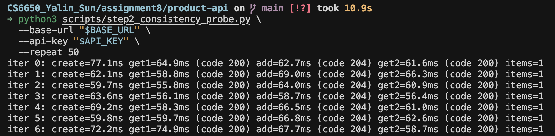

Test C: Rapid updates to the same cart from multiple clients
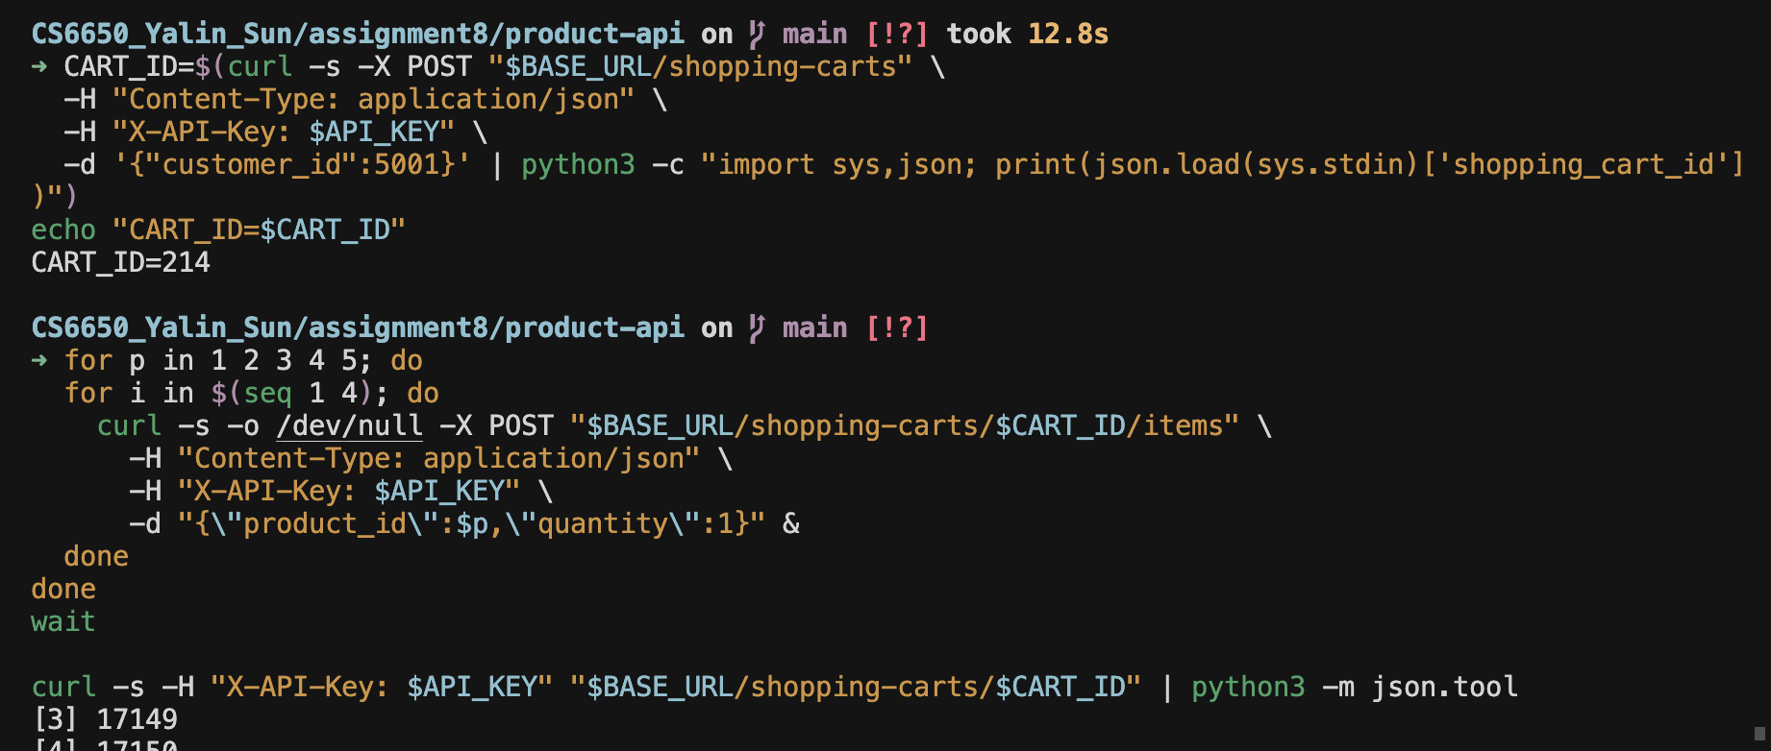
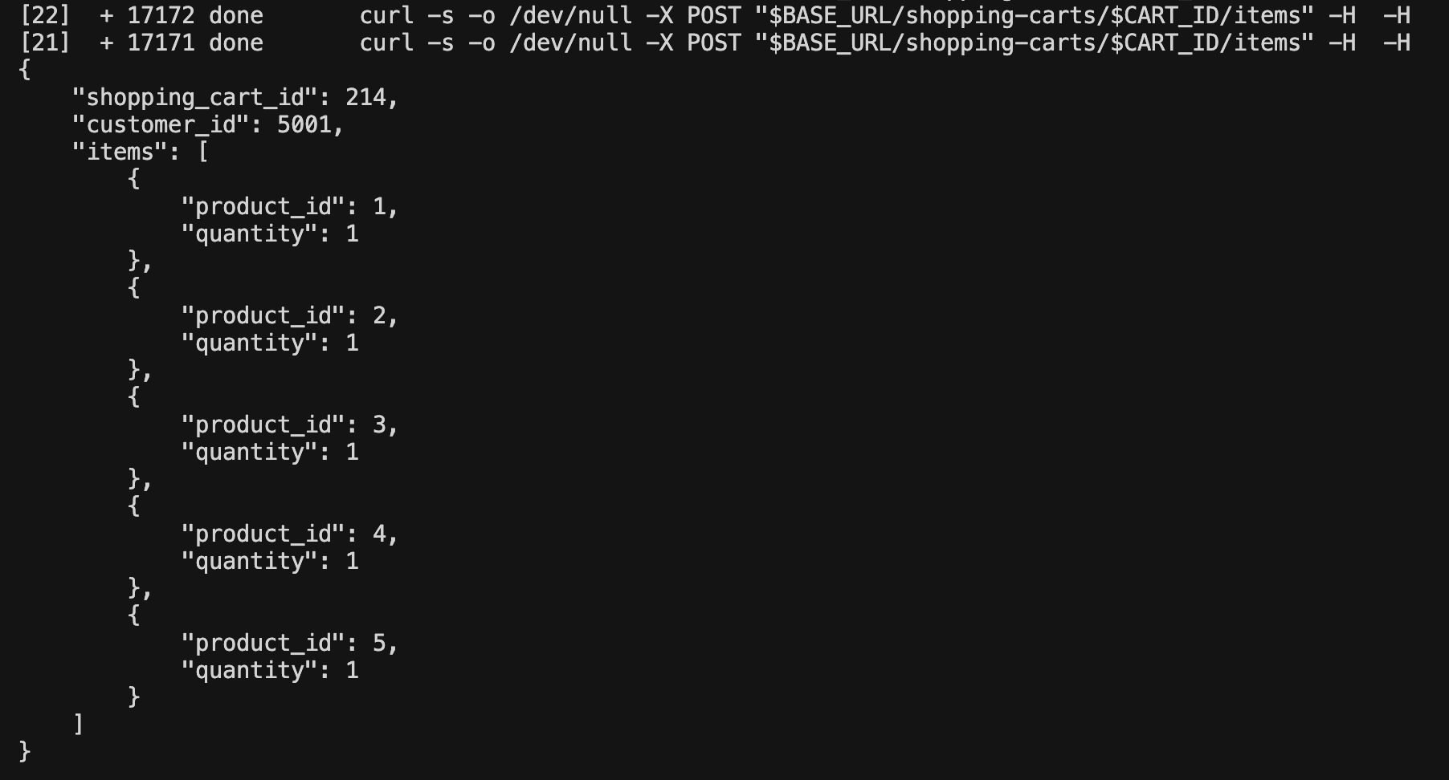
Observations
In 50 probe iterations, I observed 0 failures.
For create->get and add->get flows, responses were consistently successful.
After rapid concurrent updates on the same cart, the final cart showed all expected item entries.
I did not observe clear stale-read behavior in this run.
Why this happened
In my implementation, cart reads use DynamoDB base table keys with ConsistentRead=true for GetItem/Query. Because of this, read-after-write behavior was stable in my tests.
Investigation Questions
1) How frequently do you observe eventual consistency delays?
In my test run, the frequency was very low (effectively none in observed cases). I had 0 failures in 50 iterations for immediate read-after-write scenarios.
2) What application patterns are most affected by consistency delays?
The most affected pattern is immediate read after write, for example:
- user adds an item and immediately opens cart page,
- user updates quantity and immediately checks total. If stale reads happen, user may see old quantity or missing item.
3) How can you design your application to handle consistency gracefully?
I use strongly consistent reads for critical cart retrieval paths.
Also, a practical design is:
- short retry for immediate read-after-write,
- loading/refresh hint in UI,
- idempotent write APIs,
- avoid depending on eventually consistent index queries for critical “just-updated” data.
Part 4
1. Test Results
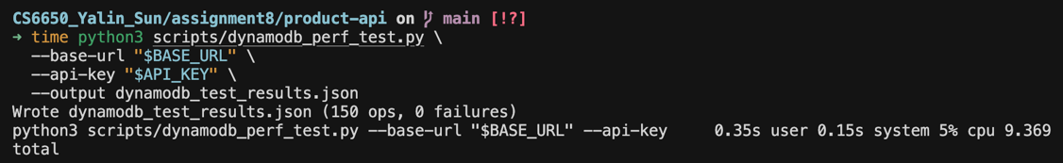
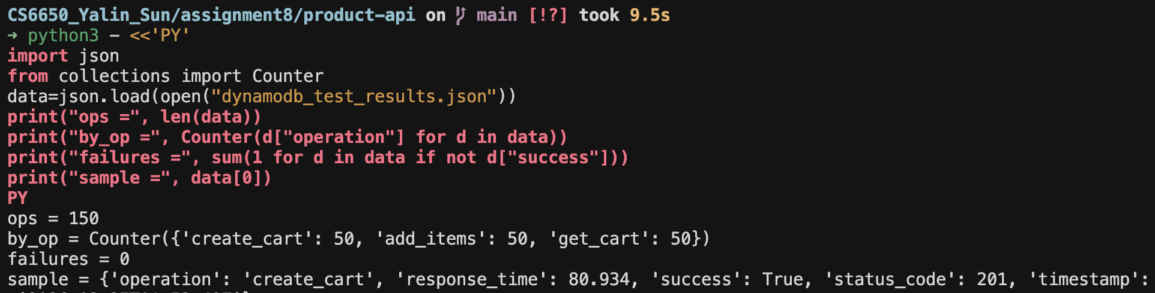
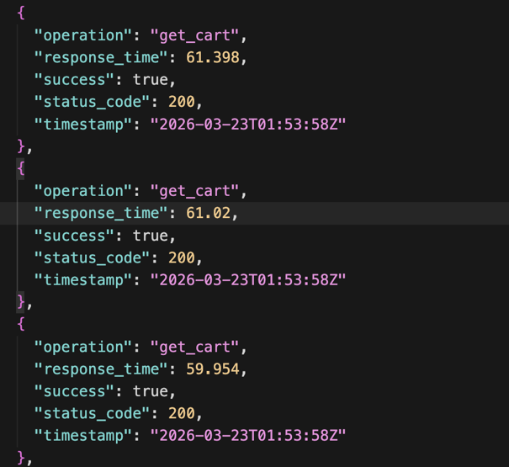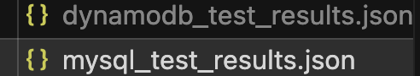
I used the same methodology as Step I for fair comparison. The test finished successfully and generated dynamodb_test_results.json.
The test is stable with 0 failures across all required operations. This means the DynamoDB implementation can support the same shopping cart API behavior as Step I.
Part 5
1. What surprised me
(1) Did partition key strategy work as expected?
Yes. I used `pk = CART#<cart_id>` and `sk` for `META` and `ITEM#<product_id>`. This design matched my access pattern (get one cart, update one cart item) and worked well in testing.
(2) Were there NoSQL concepts different from expectations?
Yes. In DynamoDB I must explicitly format attributes by type (`S`, `N`) and numbers are passed as strings in SDK attribute values. This is different from MySQL driver behavior where type mapping feels more automatic.
(3) How did eventual consistency affect testing?
In my tests, impact was low. For create->get and add->get immediate reads, I observed 0 failures in 50 iterations. One reason is I used consistent reads on base-table key access.
2. Design evolution
Partition key: At first I considered storing one full cart object in one item. Then I switched to ‘META + ITEM#...’ rows under the same ‘pk’, because item update logic is cleaner and closer to Step I line-item model.

Hot partition: I did not observe clear hot-partition symptoms in this workload.
Validation: I validated with 150-operation test, consistency probe, and CloudWatch metrics (no obvious throttling/errors). If traffic becomes much larger, I would continue monitoring key distribution and throttling.
Part 6
1. Request latency + consumed capacity
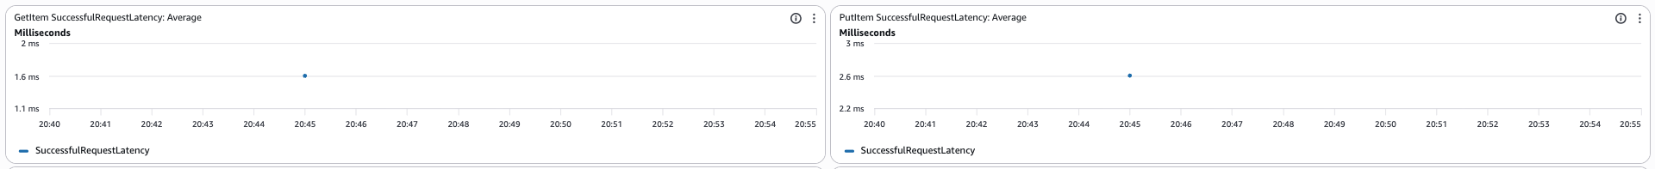
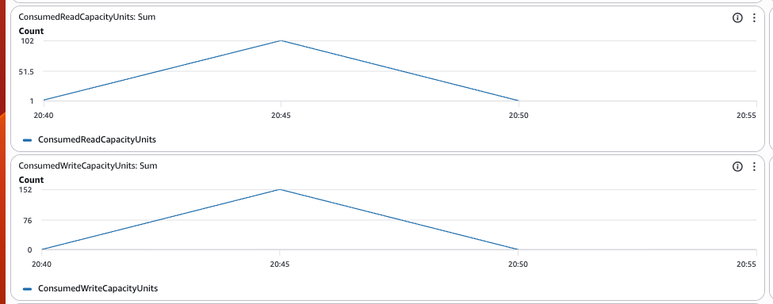
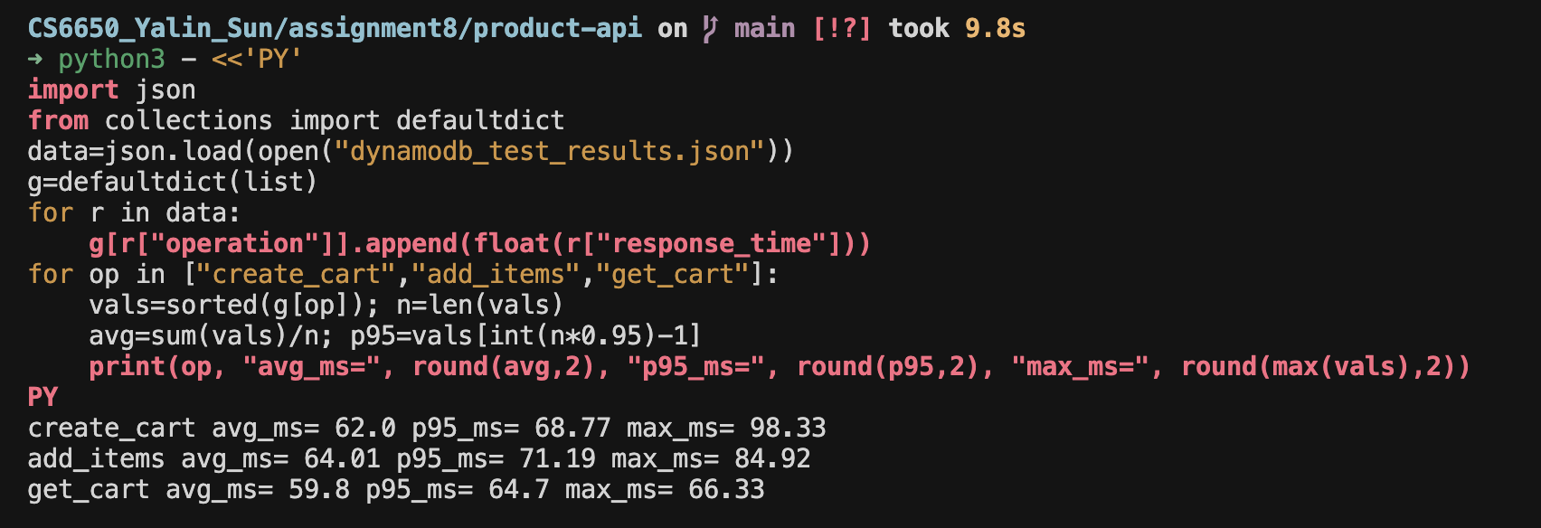
2. Throttling events
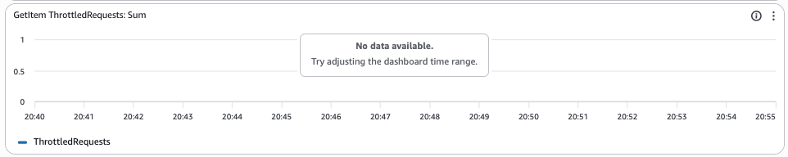
3. Partition distribution patterns
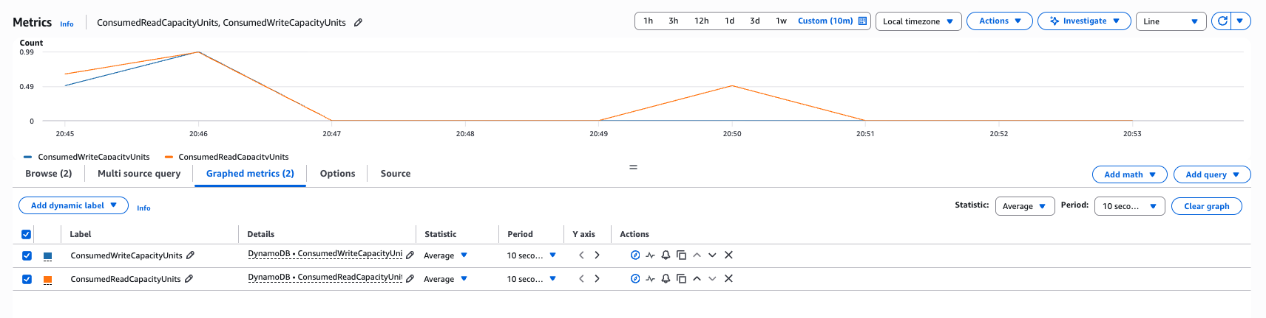
4. Error rates and types
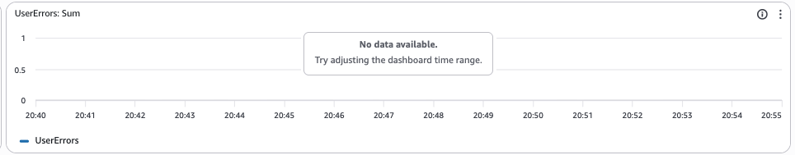
During the DynamoDB test window, I monitored request latency, consumed capacity, throttling, and error metrics in CloudWatch.
For latency, I captured successful request latency for GetItem and PutItem.
For capacity, both ConsumedReadCapacityUnits and ConsumedWriteCapacityUnits showed clear activity peaks during the test.
For throttling and errors, I observed no visible throttling events and no user-error spikes in the selected window.
This matches the API test result with stable behavior and no failures.
For partition distribution, I used indirect evidence from stable consumed-capacity curves and no throttling/error spikes.
Under this workload, I did not observe signs of hot-partition issues.
Section Report
1. Performance Testing Results
Direct comparison with Step I (MySQL)

Metric | MySQL (ms) | DynamoDB (ms)
Avg create_cart | 62.75 | 66.95
Avg add_items | 67.23 | 64.91
Avg get_cart | 63.87 | 61.12
Overall avg (150 ops) | 64.62 | 64.33
Overall p95 | 71.40 | 71.68
Max (all ops) | 204.91 | 87.17
2. Evidence partition strategy under load
The homework test is sequential (not extreme write QPS), but the design still matches DynamoDB’s model: each cart’s items sit under one partition key CART#<id>, so Query(pk = …) stays a single-partition read. Many different carts spread work across many pk values (no single “all users in one partition” key). The only fixed pk is SYSTEM for the counter; with class-scale traffic it could become hotter than cart partitions, but for this assignment it is acceptable.
3. Eventual consistency behavior
DynamoDB is eventually consistent by default, but my GET path uses ConsistentRead = true on GetItem (META) and Query (full cart). In Part 3 probes (create → immediate GET, add → immediate GET), I usually saw HTTP 200 and correct items on the first GET. So I mostly did not observe “stale read” delays in this setup; the trade-off is slightly higher read cost / latency than default reads, but simpler UX for “see my own cart right away.”
4. Implementation notes
(1) Partition key strategy and rationale
I chose pk = CART#<cartId> for cart data because the main access pattern is get one full cart and update items in that cart. Putting META and all ITEM# rows under the same pk gives one strongly consistent Query per cart load. I avoided pk = customer_id as the only key because then “list all items for one cart” would need a GSI or extra queries unless the model is redesigned.
(2) Key differences from MySQL (Step I)
Schema: MySQL uses two tables (shopping_carts, cart_items) with FK + CASCADE. DynamoDB uses one table and item types separated by sk; integrity is enforced in the app (no FK).
Queries: MySQL GET uses JOIN. DynamoDB GET uses Query + filter META / ITEM# in code.
Concurrency: MySQL uses short transactions + SELECT … FOR UPDATE for same-cart updates. DynamoDB uses atomic UpdateItem on counter and per-item PutItem; conflicts are item-level, not row-lock style.
Connection: MySQL needs a pool to RDS. DynamoDB uses HTTP API clients (no SQL pool).
(3) Eventual consistency observations
In class we learn DynamoDB replicas can lag for eventually consistent reads. For the cart UX I preferred strongly consistent reads after writes, so my tests rarely showed inconsistency. If I switched to default reads or added GSIs with eventual consistency, I would expect more “sometimes old data” and would add retry/backoff or version fields in the UI.
(4) NoSQL vs SQL trade-offs discovered
SQL pros: Clear relational model, FK integrity, easy ad-hoc SQL for grading/history queries.
NoSQL pros: Fits access-pattern-first design, horizontal scale story, single-partition Query for one cart.
NoSQL cons: More application-side rules, careful hot key thinking (SYSTEM counter), and no built-in JOIN/FK so “customer purchase history by customer” needs a GSI (customer_id) or a second access pattern if we really want it at DB level.
STEP III: Database Comparison & Analysis
Part 1
1. Comparison Table
Metric | MySQL | DynamoDB | Winner | Margin
Avg Response Time (ms) | 64.62 | 64.33 | DynamoDB | DynamoDB faster by 0.29 ms
P50 Response Time (ms) | 63.20 | 63.78 | MySQL | MySQL faster by 0.58 ms
P95 Response Time (ms) | 71.40 | 71.68 | MySQL | MySQL faster by 0.27 ms
P99 Response Time (ms) | 83.15 | 84.72 | MySQL | MySQL faster by 1.56 ms
Success Rate (%) | 100.00 | 100.00 | tie | 0
Total Operations | 150 | 150 | — | —
2. Operation-Specific
Operation | MySQL Avg (ms) | DynamoDB Avg (ms) | Faster By
CREATE_CART | 62.75 | 66.95 | MySQL ~4.20 ms
ADD_ITEMS | 67.23 | 64.91 | DynamoDB ~2.32 ms
GET_CART | 63.87 | 61.12 | DynamoDB ~2.76 ms
3. Consistency Model Impact Assessment

(1) Actual behavior observed
In my Step II tests (create → GET, add → GET), I usually got HTTP 200 and correct cart items on the first GET. I did not see many “stale read” problems in practice because my DynamoDB reads for the cart use consistent reads (ConsistentRead=true on GetItem / Query).
(1) How eventual consistency affected my app
For this homework implementation, the effect was small after I enabled strong reads on the cart path. If I used default eventually consistent reads to save cost, I might sometimes read old data right after a write, especially under higher load or with GSI.
(3) ACID (MySQL) vs eventual (DynamoDB default)
MySQL uses InnoDB transactions (ACID), so after COMMIT the next read sees the new state. DynamoDB is eventually consistent by default across replicas, but strongly consistent reads are available for some calls. In my project, I chose strong reads for cart GET so the behavior is closer to “read my own write.”
(4) User experience
If users see wrong quantities after clicking “add”, they lose trust. Strong reads for cart help. For non-critical data (e.g. recommendation counts), eventual consistency can be OK with a short “loading” state.
4. Analysis framework
(1) How often consistency delays?
In my probes, almost never for the cart API with strong reads. If I turned off consistent reads, I would expect more delays, but I did not measure that in the main 150-op test.
(2) Which patterns are most affected?
Patterns that read right after write with eventually consistent paths or GSI reads; also high write then immediate read on the same item without strong read.
(3) How to design for each model?
MySQL / transactional: use short transactions and clear error handling. DynamoDB: use strong reads when the user must see their own update; otherwise add retry + refresh in the UI, or show version / timestamp to detect stale data.
Part 2
1. Resource patterns (MySQL vs DynamoDB)
In my Step I code, the app uses a MySQL connection pool to RDS. I need to set max open / idle connections and handle connection errors. RDS also needs VPC, security groups, subnet group, so there is more ops work at the start.
For Step II, DynamoDB is serverless-style for me: no JDBC-style pool. The app uses the AWS SDK and IAM role on ECS. Capacity is on-demand (PAY_PER_REQUEST), so I do not pick instance size for the table like RDS db.t3.micro.
2. Predictability & capacity planning
RDS is more predictable in cost shape if I know instance class, but I can hit CPU / connection limits if traffic grows. I must scale instance or tune the pool. DynamoDB on-demand auto-scales throughput for the table, but cost follows read/write requests and I must watch hot partitions in the data model. So planning is different: “pick instance” vs “watch access patterns and billing”.
3. Operational complexity
MySQL + RDS felt heavier: network path to RDS, schema migration, SQL tuning. DynamoDB felt different: IAM permissions, single-table design, and understanding consistency options—not easier, just different problems.
4. Scaling analysis — how requirements change with load
For MySQL, higher load usually means more connections, more CPU, longer queries, and maybe read replicas later. For DynamoDB, higher load increases request count and per-partition traffic; throttling is less common on on-demand, but hot keys can still be a problem.
5. Which is more predictable?
RDS instance metrics (CPU, connections) are easy to watch in one place. DynamoDB per-table metrics are clear too, but end-to-end latency in my tests was similar, so predictability of performance was not very different at homework scale—predictability of ops depends on whether my team is stronger in SQL or in AWS NoSQL.
6. Capacity planning implications
MySQL/RDS: choose instance size, storage, connection limits, maybe vertical scaling first. DynamoDB: focus on partition key design, consistent reads vs cost, and monthly request cost; add GSI only when access patterns need it.
Part 3
Scenario A — Startup MVP (100 users/day, 1 developer, limited budget, quick launch)
My Recommendation: MySQL (Amazon RDS)

Key Evidence: In my 150-op test from combined_results.json, overall average latency was ~64.6 ms (MySQL) vs ~64.3 ms (DynamoDB), so performance is basically the same for this homework traffic. For an MVP, the bigger issue is delivery speed and simple debugging. I already have a small relational schema (carts + line items) and SQL queries that are easy to change. RDS db.t3.micro is a clear budget choice for class projects. So I pick MySQL here not because it was much faster in the test, but because relational modeling + one RDS instance is straightforward for one developer.
Scenario B — Growing Business (10K users/day, 5 developers, moderate budget, feature expansion)
My Recommendation: MySQL (RDS), still primary — with a plan for read scaling later
Key Evidence: My measured p95 was still only ~71 ms for both backends at homework load, so the bottleneck is not shown yet. For a growing product, teams often add reports, admin queries, and new relational features. SQL + migrations fit that better than redesigning access patterns for every feature. Operationally, connection pooling is a known pattern (I configured a pool in the app). I would keep MySQL as the main store for cart + relational data, and only move a narrow hot path to NoSQL later if metrics prove it.
Scenario C — High-Traffic Events (50K normal, 1M spike, revenue-critical, can invest)
My Recommendation: DynamoDB (on-demand) for the hot cart path
Key Evidence: My end-to-end numbers were still ~64 ms average for both, but that test is not a spike test. For a 1M-user spike, RDS can hit connection limits and CPU unless we add bigger instances, read replicas, and careful tuning. DynamoDB on-demand can absorb bursty traffic without pre-picking instance size for the database layer. My cart design uses one partition key per cart (CART#id), which helps spread carts across partitions. So I recommend DynamoDB for the write-heavy cart during events, and keep MySQL for other relational data if needed (polyglot pattern).
Scenario D — Global Platform (millions of users, multi-region, 24/7, enterprise)
My Recommendation: DynamoDB (e.g., Global Tables) for multi-region cart/session scale-out; MySQL/Aurora for global relational data where strong SQL is needed
Key Evidence:
My tests were single-region only, so I cannot “prove” multi-region latency here. From implementation experience, DynamoDB has a clearer story for multi-region active-active patterns (Global Tables) for key-value access. Running MySQL across many regions with low lag usually means Aurora Global Database or async replication, which is heavier operationally. For millions of users, I would put high-churn session/cart state on DynamoDB, and use SQL/Aurora for orders/inventory where FKs and transactions matter more.
Part 4
1. Shopping Cart Winner:
DynamoDB. In my test, add and get (the common path) were a bit faster; overall avg was almost the same (~64.3 ms vs ~64.6 ms).
2. Supporting Evidence
GET_CART / ADD_ITEMS: DynamoDB lower avg than MySQL (from combined_results.json).
CREATE_CART: MySQL was faster, but create runs less often than get/add.
Success rate: 100% for both.
1) Response time advantage
Overall avg: ~0.3 ms (small). GET ~2.8 ms, ADD ~2.3 ms faster on DynamoDB in my averages.
2)Implementation complexity
MySQL: RDS + pool + SQL + transactions. DynamoDB: IAM + pk/sk design + no connection pool. Both need work; SQL was more familiar for me.
3) Other factors
Strong reads on cart GET → few stale reads. MySQL has FK/ACID; DynamoDB needs app-level rules.
3. When to choose the other (MySQL)
If we need FK + SQL reports + big multi-table transactions in one DB.
1) What requirements would change your recommendation?
- Need multi-table transactions with strict isolation for cart + inventory + payment in one database transaction → MySQL (or another relational DB) becomes more attractive.
- Need very high write/read spikes and simple key-based cart access with minimal connection management → DynamoDB fits better.
- Need ad-hoc analytics on cart tables by many columns → SQL is usually easier.
2) What use case characteristics favor the alternative (MySQL)?
Heavy joins, reporting, admin dashboards, batch jobs, strong FK rules, and teams that are more comfortable with SQL than with NoSQL access-pattern design.
4. Polyglot Strategy
Area | Choice | Short reason (based on patterns learned)
Shopping carts | DynamoDB | My add/get numbers were slightly better; key-based Query per cart; good for bursty traffic (with honest note: my test is small).
User sessions | DynamoDB or ElastiCache (Redis) | Sessions look like key-value with TTL; Redis is common; DynamoDB also works if we want serverless sessions.
Product catalog | MySQL (or Aurora) | Products have many attributes, filters, search; relational model + SQL is easier for complex queries (or add OpenSearch later).
Order history | MySQL / Aurora | Orders need ACID, FKs, reporting, refunds — relational DB is a natural fit.
Part 5
1. What surprised me
I expected DynamoDB to be much faster than MySQL, but in my test data the overall latency was very close (both around mid-60 ms average in combined_results.json).
A surprising point is MySQL was faster for CREATE_CART, while DynamoDB was faster for ADD_ITEMS and GET_CART.
I also learned that “database speed” is not the only factor; network path and deployment state can dominate end-to-end response time.
Another surprise: with strongly consistent reads in DynamoDB cart queries, I did not see many stale-read problems in my probe.
2. What failed initially
At first, my service had timeout issues because ECS subnet/public access setup was not correct. Later I got API success responses, but DynamoDB table looked empty; the main problem was old task/image deployment, not API logic only.
I also hit ExpiredTokenException, so some debugging time was about AWS credentials, not code.
For monitoring, I initially could not see consumed capacity metrics until I confirmed region/table and generated real traffic again.
These failures taught me to verify deployment/runtime state first, then debug application code.
3. Key insights gained
I would definitely choose MySQL when I need strong relational constraints, SQL joins, and clear transactional behavior across related tables.
I would definitely choose DynamoDB for key-based access patterns, bursty traffic, and simpler no-connection-pool operation in app code.
If I advise another student, I will say: first make sure your running ECS task really uses your latest image and correct backend env vars, then do performance tests.
Hands-on work changed my understanding: SQL vs NoSQL is not “which is always faster”; it is mostly about access pattern, consistency choice, and operational model.

